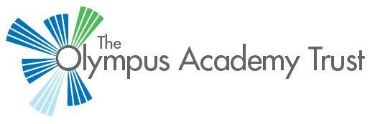

**Notice of proposed changes to:**

1. **The over-subscription criteria for school admissions at Patchway Community School and Winterbourne Academy**
2. **The Planned Admission Number (PAN) at Stoke Lodge Primary School**

The Olympus Academy Trust is consulting on the proposed admission arrangements for the academic year 2020/21. The consultation will be open from 17th December 2018 to 1st February 2019.

1. A proposal to alter the over-subscription criteria for Patchway Community School and Winterbourne Academy to bring them in line with the other secondary schools in the Trust.

The current over-subscription criteria for allocation of places are:

1. Children in Public Care or previously in Public Care
2. Siblings living within the Area of Prime Responsibility (APR)
3. Children living within the APR, closest first
4. Children living outside the APR, closest first

It is proposed to alter the 4th criterion to:

4a. Siblings living outside the APR, closest first

4b. Non-siblings living outside the APR, closest first

1. A proposal to reduce the PAN at Stoke Lodge Primary School from 90 to 60.

The full draft policy can be read at <https://www.olympusacademiestrust.org.uk/>. Paper copies are also available on request. Feedback, comments, queries and requests for copies of the policy should be addressed to**:**

**Lisa Stevens, Olympus Academy Trust Admissions Officer**

**Winterbourne Academy, 17 High Street, Winterbourne, Bristol BS36 1JL**

**Tel: 01454 252010**

**Email:** [lisa.stevens@olympustrust.co.uk](mailto:lisa.stevens@olympustrust.co.uk)

December 2018