FRENCHAY HOSPITAL UPDATE  The following article was provided by Dan Bramwell, Bramwell Associates.  2017 has been a busy year on the former Frenchay Hospital site as house builder Redrow started building at Frenchay Park, phase 1 of the development.  By the end of the year thirteen families had taken up residence on the Frenchay Park site and this number will increase drastically over the months to come. Work on Phase 2 (Frenchay Gardens) has also begun. These two phases alone will deliver a mix of private and affordable housing and are the anchor for the entire development.  In late 2017 a further four planning applications were submitted covering the remainder of the site and these will work their way through the South Gloucestershire Council planning system during the first few months of 2018.  The summary for each application is:  - Phase1 (Frenchay Park) - construction underway: 10 completions; 5 reservations and 7 exchanged plots awaiting completion with a further10 plots available.  - Phase 2 (to be called Frenchay Gardens) - planning permission has now been approved and work will get underway imminently  - Phase 3A - Reserved Matters Application has been submitted and is currently out for consultation. Reference is PT17/4904/RM and constitutes 30 privately marketed and 11 social rented units  - Phase 4 was submitted during mid-November and has been validated. Reference is PT17/5363/RM. This phase includes Lime Tree Avenue and constitutes 113 private dwellings and a total of 30 affordable housing units, 9 of which will be shared ownership and 21 social rented  - Phase 3B was submitted at the beginning of December and comprises a total of 66 dwellings, 48 of which are private and 18 affordable, all social rented.  A further reserved matters application has been submitted for 23 dwellings, of which 17 are private, 4 social rented and 2 shared ownership, on part of the land identified for ‘possible healthcare provision’ to the north of Phase 1. Thus the total number of units applied for on the entire site is 366 private and 112 affordable housing units of which 87 are social rented and 25 shared ownership.  Finally, the Landscape Infrastructure Masterplan has been agreed and the management and maintenance responsibilities are currently being discussed among the various parties. |  |  | WINTERBOURNE PARISH COUNCIL  WINTER NEWSLETTER  The Councillors and Staff at the Greenfield Centre wish you all a very Happy and Healthy New year  The Greenfield Centre  It has been a sad time within the Council due to the passing of one of our longstanding Councillors John Godwin and our Clerk Lyn Iles. Their passing will be a huge loss to the Parish Council. We say goodbye to John Lowe our Groundsman who has retired after many years working for the Parish Council. We wish him well in his retirement.  We welcome our new Clerk Sally Watkinson and her Assistant Kelly Fry who are available at the Greenfield Centre between Monday – Friday 9.00am – 2.00pm and they will be happy to help you if you need to contact them.  The Greenfield Centre has three rooms which are available for rent to the public. Many activities take place at the Greenfield Centre full details are on the Parish Council website: winterbourneparishcouncil.org.uk or for more details contact the Clerk on 01454 776922.  Launch of the New Skate Park  We were pleased in October 2017 to launch our new skate park at the Recreational Ground. This was officially opened by The Mayor of the West of England, Tim Bowles (former District Councillor for Winterbourne). We instructed park designers Wheelscape to deliver this project. Mayor Tim explained “it was important to keep it as local as possible and when we had the old skate ramp on the site tested for metal fatigue it was found to be dangerous so the decision was made to remove it straight away. The Parish wanted to design something for the youth of the village to enjoy and are very pleased with this one that has been created”.  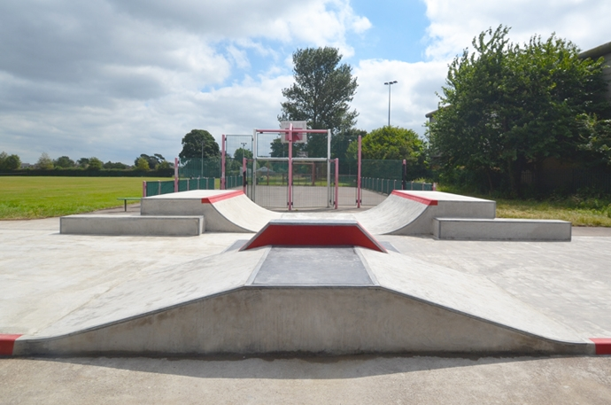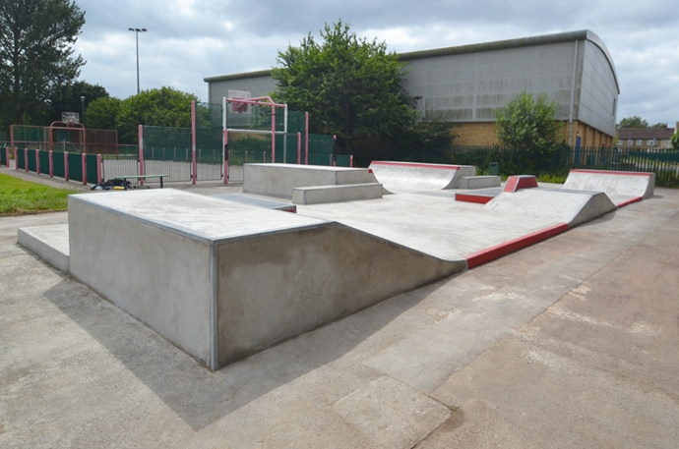  We have received good feedback from many users of various ages since it has been installed and hope that this continues.

